EU DECLARATION OF CONFORMITY

in accordance with
Annex VI of Directive 2014/53/EU of the European Parliament and of the Council
1.For the following Radio equipment:
Model: XE31
Product: TWS Earphone
Trade name or Brand: Infinix
Software / Hardware number: V2.3.5/ V0.1
2. Name and address of the manufacturer or his authorized representative:
Manufacturer: INFINIX MOBILITY LIMITED
Address: FLAT N 16/F BLOCK B UNIVERSAL INDUSTRIAL CENTRE 19-25 SHAN MEI STREET FOTAN NT HONGKONG
3. This declaration of conformity is issued under the sole responsibility of the Manufacturer.
4. Object of the declaration (identification of the radio equipment allowing traceability; it may include a colour image of sufficient clarity where necessary for the identification of the radio equipment):
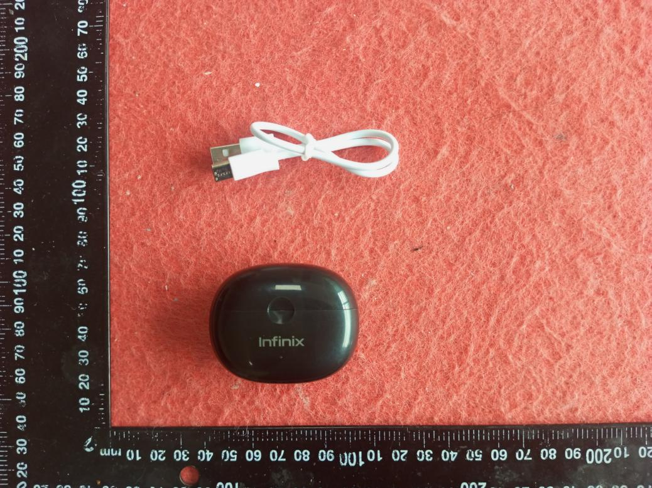

5. The object of the declaration described above is in conformity with the relevant Union harmonization legislation: Directive 2014/53/EU (RED)

- References to the relevant harmonised standards used or references to the other technical specifications in relation to which conformity is declared:

Article 3.1a Health:
EN 62479:2010

Article 3.1a Electrical Safety:
EN62368-1:2014+A11:2017
EN IEC 62368-1:2020+A11:2020

Article 3.1b:
ETSI EN 301 489-1 V2.2.3 (2019-11)
ETSI EN 301 489-17 V3.2.4 (2020-09)

Article 3.2:
ETSI EN 300 328 V2.2.2 (2019-07)

7. Notified Body Name: Eurofins Electrical and Electronic Testing NA, Inc.
Notified Body Number: 0980
Notified Body Assessment Performed: Module B/C on Article 3.1a, 3.1b, 3.2
Technical File Identification Number: N/A

8. Where applicable, description of accessories and components, including software, which allow the radio equipment to operate as intended and covered by the EU declaration of conformity: User instructions are provided in the User Manual. The Software and Hardware versions are specified above.

9. Additional information:
Referring to Article 10.2 of the Directive, this equipment is so constructed that it can be operated in all Member States, without infringing applicable requirements on the use of radio spectrum.
Referring to Article 10.10 of the Directive, there are no restrictions on putting this equipment into service or of requirements for authorisation of use. Please refer to the User Manual for details.

On behalf of:

Manufacturer: INFINIX MOBILITY LIMITED
Address: FLAT N 16/F BLOCK B UNIVERSAL INDUSTRIAL CENTRE 19-25 SHAN MEI STREET FOTAN NT HONGKONG

(place and date of issue):Shenzhen, 2024-04-01
(name, function):YangDaozhuang/ Manager

(signature):
(Name and signature of person responsible)

